TASK 3.1:JAVA DATE AND TIME:
PROGRAM:
import java.io.*;
import java.math.*;
import java.security.*;
import java.text.*;
import java.util.*;
import java.util.concurrent.*;
import java.util.function.*;
import java.util.regex.*;
import java.util.stream.*;
import static java.util.stream.Collectors.joining;
import static java.util.stream.Collectors.toList;
import java.time.LocalDate;
class Result {
public static String findDay(int month, int day, int year) {
LocalDate date = LocalDate.of(year, month, day);
return date.getDayOfWeek().name();
}
}
public class Solution {
public static void main(String[] args) throws IOException {
BufferedReader bufferedReader = new BufferedReader(new InputStreamReader(System.in));
BufferedWriter bufferedWriter = new BufferedWriter(new FileWriter(System.getenv("OUTPUT_PATH")));
String[] firstMultipleInput = bufferedReader.readLine().replaceAll("\\s+$", "").split(" ");
int month = Integer.parseInt(firstMultipleInput[0]);
int day = Integer.parseInt(firstMultipleInput[1]);
int year = Integer.parseInt(firstMultipleInput[2]);
String res = Result.findDay(month, day, year);
bufferedWriter.write(res);
bufferedWriter.newLine();
bufferedReader.close();
bufferedWriter.close();
}
}
OUTPUT:
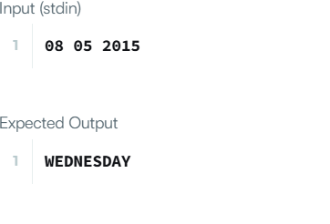
TASK 3.2:NUMBER OF DATES BETWEEN TWO DATES:
PROGRAM:
import java.time.LocalDate;
import java.time.temporal.ChronoUnit;
class Solution {
public int daysBetweenDates(String date1, String date2) {
LocalDate d1 = LocalDate.parse(date1);
LocalDate d2 = LocalDate.parse(date2);
long daysBetween = Math.abs(ChronoUnit.DAYS.between(d1, d2));
return (int) daysBetween;
}
}
OUTPUT:
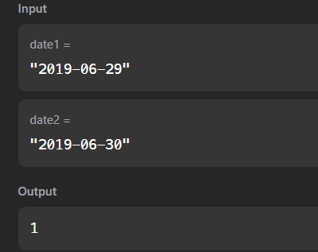

TASK 3.3:DAYS OF THE YEAR
PROGRAM:
import java.time.LocalDate;
class Solution {
public int dayOfYear(String date) {
return LocalDate.parse(date).getDayOfYear();
}
}
OUTPUT:
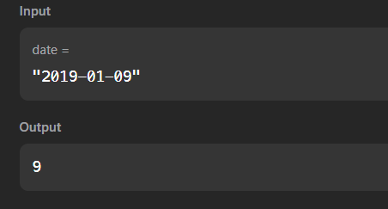

TASK 3.4:DAYS OF THE WEEK
PROGRAM:
import java.time.LocalDate;
class Solution {
public String dayOfTheWeek(int day, int month, int year) {
String dayName = LocalDate.of(year, month, day).getDayOfWeek().name();
return dayName.substring(0, 1) + dayName.substring(1).toLowerCase();
}
}
OUTPUT:
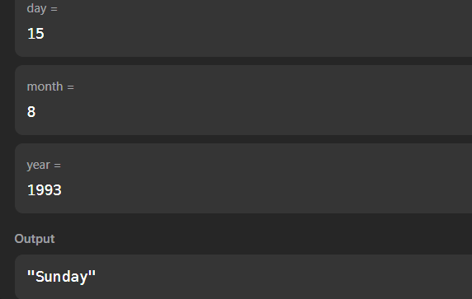

TASK 3.5:JAVA PRIORITY QUEUE
PROGRAM:
import java.util.ArrayList;
import java.util.List;
import java.util.Scanner;
import java.util.PriorityQueue;
class Student implements Comparable<Student> {
private int id;
private String name;
private double cgpa;
public Student(int id, String name, double cgpa) {
this.id = id;
this.name = name;
this.cgpa = cgpa;
}
public int getID() {
return id;
}
public String getName() {
return name;
}
public double getCGPA() {
return cgpa;
}
@Override
public int compareTo(Student other) {
if (Double.compare(other.cgpa, this.cgpa) != 0) {
return Double.compare(other.cgpa, this.cgpa);
}
if (!this.name.equals(other.name)) {
return this.name.compareTo(other.name);
}
return Integer.compare(this.id, other.id);
}
}
class Priorities {
public List<Student> getStudents(List<String> events) {
PriorityQueue<Student> pq = new PriorityQueue<>();
for (String event : events) {
String[] parts = event.split(" ");
if (parts[0].equals("ENTER")) {
String name = parts[1];
double cgpa = Double.parseDouble(parts[2]);
int id = Integer.parseInt(parts[3]);
pq.add(new Student(id, name, cgpa));
} else if (parts[0].equals("SERVED")) {
pq.poll();
}
}
List<Student> students = new ArrayList<>();
while (!pq.isEmpty()) {
students.add(pq.poll());
}
return students;
}
}

public class Solution {
private final static Scanner scan = new Scanner(System.in);
private final static Priorities priorities = new Priorities();
public static void main(String[] args) {
int totalEvents = Integer.parseInt(scan.nextLine());
List<String> events = new ArrayList<>();
while (totalEvents-- != 0) {
String event = scan.nextLine();
events.add(event);
}
List<Student> students = priorities.getStudents(events);
if (students.isEmpty()) {
System.out.println("EMPTY");
} else {
for (Student st: students) {
System.out.println(st.getName());
}
}
}
}
OUTPUT:
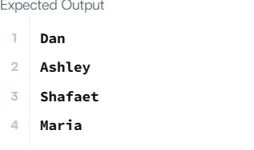

TASK 3.6: JAVA ARRAY LIST
PROGRAM:
import java.io.*;
import java.util.*;
public class Solution {
public static void main(String[] args) {
Scanner sc = new Scanner(System.in);
if (!sc.hasNextInt()) return;

int n = sc.nextInt();
ArrayList<ArrayList<Integer>> lines = new ArrayList<>();
for (int i = 0; i < n; i++) {
int d = sc.nextInt();
ArrayList<Integer> line = new ArrayList<>();
for (int j = 0; j < d; j++) {
line.add(sc.nextInt());
}
lines.add(line);
}
int q = sc.nextInt();
for (int i = 0; i < q; i++) {
int x = sc.nextInt();
int y = sc.nextInt();
try {
System.out.println(lines.get(x - 1).get(y - 1));
} catch (IndexOutOfBoundsException e) {
System.out.println("ERROR!");
}
}
sc.close();
}
}

OUTPUT:
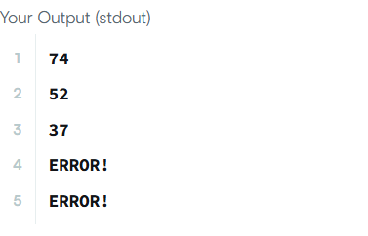

TASK 3.7: LARGEST NUMBER
PROGRAM:
import java.util.Arrays;
import java.util.Comparator;
class Solution {
public String largestNumber(int[] nums) {
String[] strs = new String[nums.length];
for (int i = 0; i < nums.length; i++) {
strs[i] = String.valueOf(nums[i]);
}
Arrays.sort(strs, new Comparator<String>() {
@Override
public int compare(String a, String b) {
String order1 = a + b;
String order2 = b + a;
return order2.compareTo(order1);
}
});
if (strs[0].equals("0")) {
return "0";
}

StringBuilder sb = new StringBuilder();
for (String str : strs) {
sb.append(str);
}
return sb.toString();
}
}
OUTPUT:
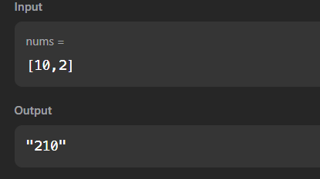

TASK 3.8: JAVA COMPARATOR
PROGRAM:
import java.util.*;
class Checker implements Comparator<Player> {
@Override
public int compare(Player a, Player b) {
if (a.score == b.score) {
return a.name.compareTo(b.name);
}
return Integer.compare(b.score, a.score);
}
}
class Player{
String name;
int score;
Player(String name, int score){
this.name = name;
this.score = score;
}
}
class Solution {
public static void main(String[] args) {
Scanner scan = new Scanner(System.in);
int n = scan.nextInt();
Player[] player = new Player[n];
Checker checker = new Checker();
for(int i = 0; i < n; i++){
player[i] = new Player(scan.next(), scan.nextInt());
}
scan.close();
Arrays.sort(player, checker);
for(int i = 0; i < player.length; i++){
System.out.printf("%s %s\n", player[i].name, player[i].score);
}
}
}

OUTPUT:
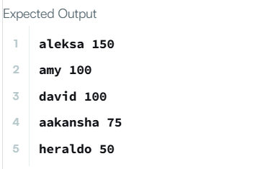

TASK 3.9: SORT THE PEOPLE
PROGRAM:
import java.util.stream.IntStream;
class Solution {
public String[] sortPeople(String[] names, int[] heights) {
return IntStream.range(0, names.length)
.boxed()
.sorted((i, j) -> Integer.compare(heights[j], heights[i]))
.map(i -> names[i])
.toArray(String[]::new);
}
}

OUTPUT:
